

VA BTSSS - Travel Pay Status Page

July 8, 2024 | Travel Pay Status Page

Version 1.0 (MVP)

Revision History

| Date | Version | Description | Author |
| --- | --- | --- | --- |
| 06/12/2024 | 1 | Product Debut | Ayush Chakravarty |

Table of Contents (**CUSTOMIZE AS NEEDED**)

**1. Product Overview 4**

**2. User Access 5**

**3. Navigation 5**

**4. Functionality 6**

**5. Major Issues and Error Messages 6**

## 1. Product Overview

The VA Travel Pay Status Page is a preliminary effort to enable users to access their information about the status of already-submitted travel reimbursement claims and provide information on how to take action on them. At this point, no action can be taken on the claims through this page. Users are required to access the BTSSS portal. The page is available to users with LOA3 credentials.

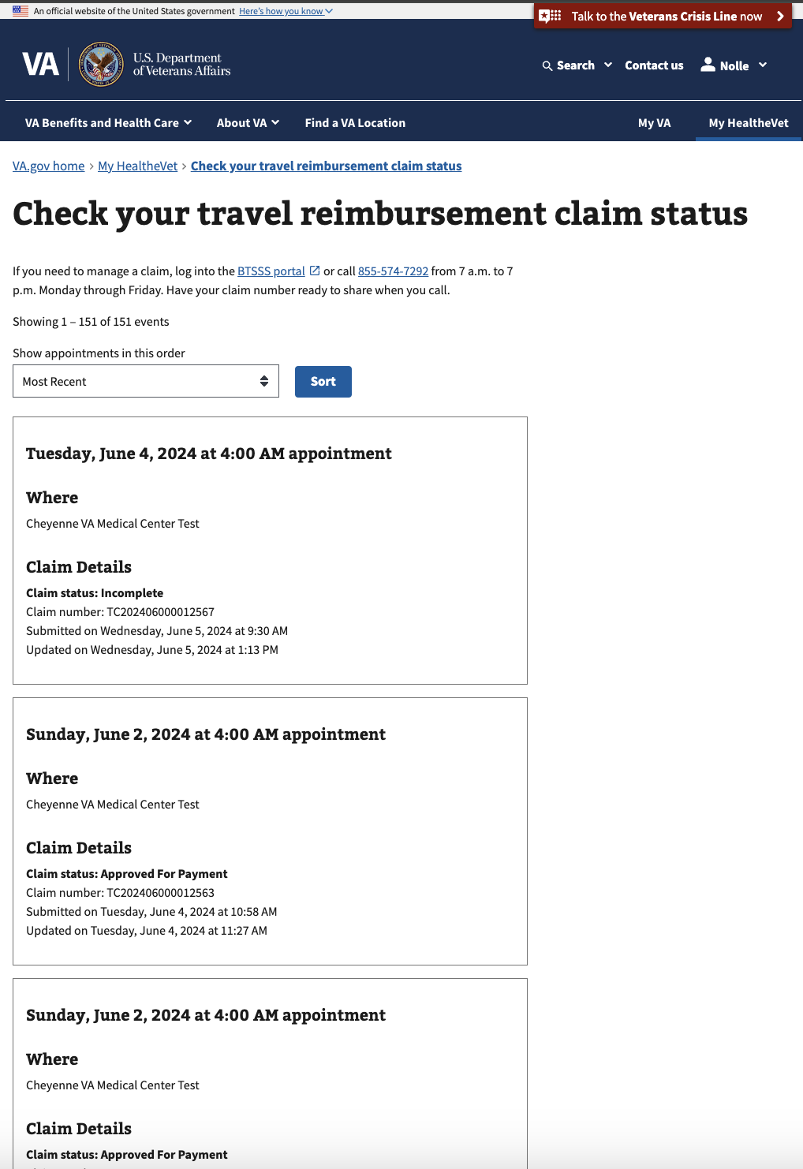

## 2. User Access

Users must be authenticated to access this page at [https://va.gov/my-health/travel-claim-status](https://staging.va.gov/my-health/travel-claim-status). In order to see content, users must have at least one travel claim.

## 3. Navigation

If users have more than one claim, they are able to sort by date and filter by status.

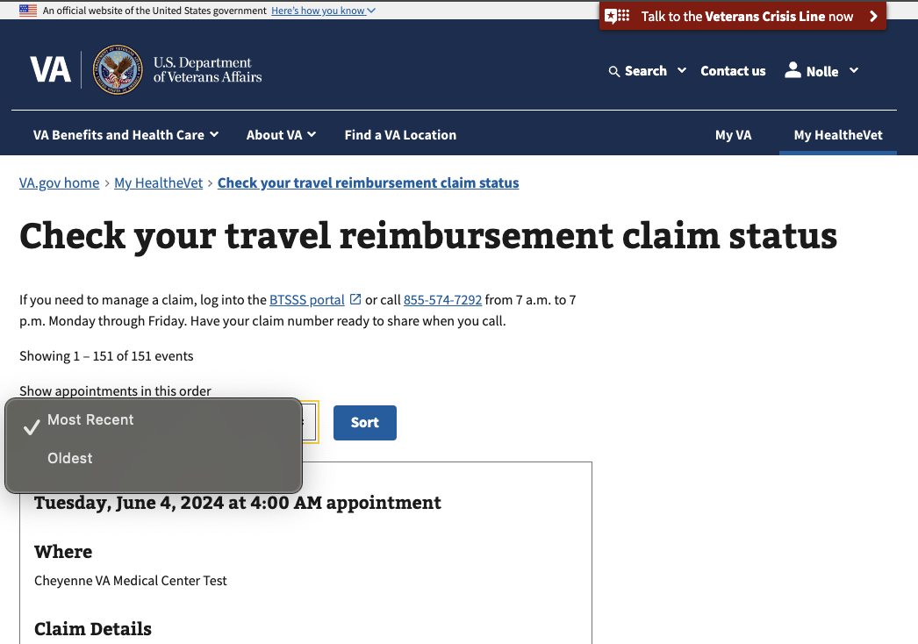

There is also pagination available. If the user has more than 10 claims, they can also click through to additional pages to see more claims.

## 4. Functionality

Each card is linked to a specific travel reimbursement claim, which is linked to an appointment. Each card contains:

* The date of the appointment
* The location of the appointment
* Claim details
  + Status
  + Number
  + Submission date
  + Last updated date

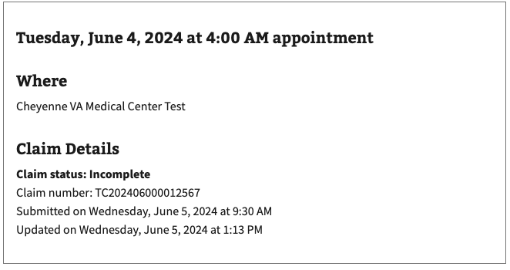

## 5. Major Issues and Error Messages

There are no known issues at this time. Users should be able to see all claims that they have submitted electronically, though at this time there is no record of paper claims.

*Figure 2. A brief caption, 9-point italic.*

**Table of Figures**

Figure 1: Caption 1

Figure 2: Caption 2